**Operating Systems**

**Lab**

**Setting Up a Virtual Server on Microsoft Azure**

1. Azure Codes will be distributed at the start of the lab session.
2. Go [www.microsoftazurepass.com](http://www.microsoftazurepass.com/) to redeem your Azure code.
3. Enter the code below and set the country to Ireland.

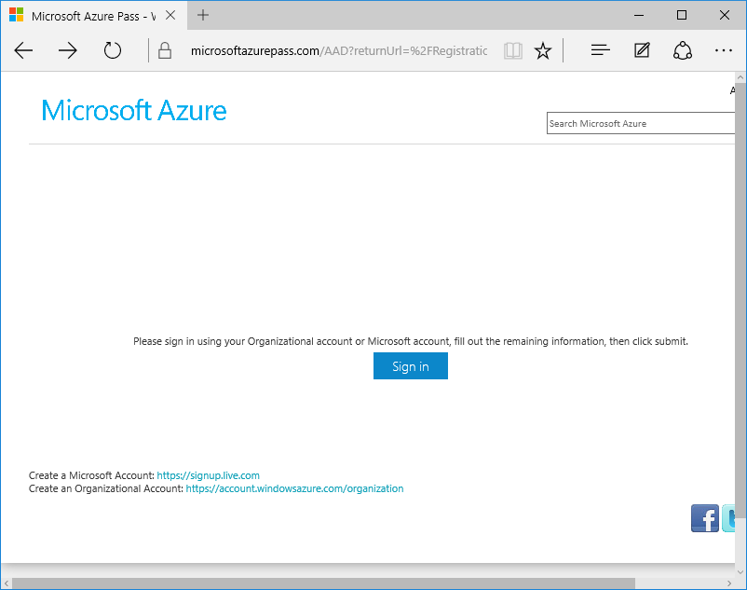

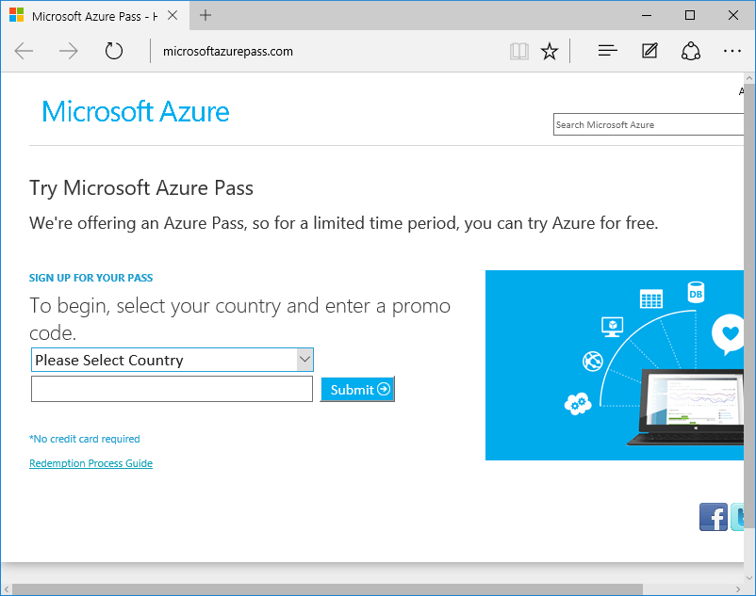

**Signing into Microsoft Azure**

1. Go the following URL <https://manage.windowsazure.com>
2. Enter your GMIT outlook log-in details
3. You should then see the following screen

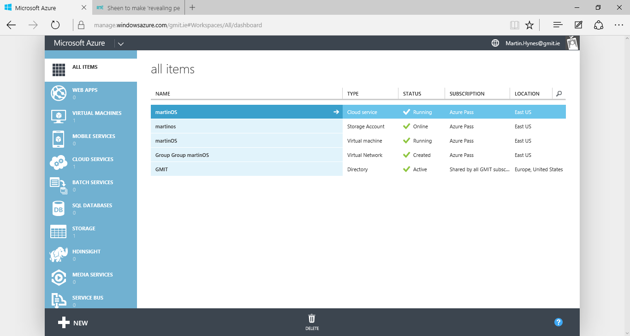

1. Click on Virtual Machines – Followed by +NEW

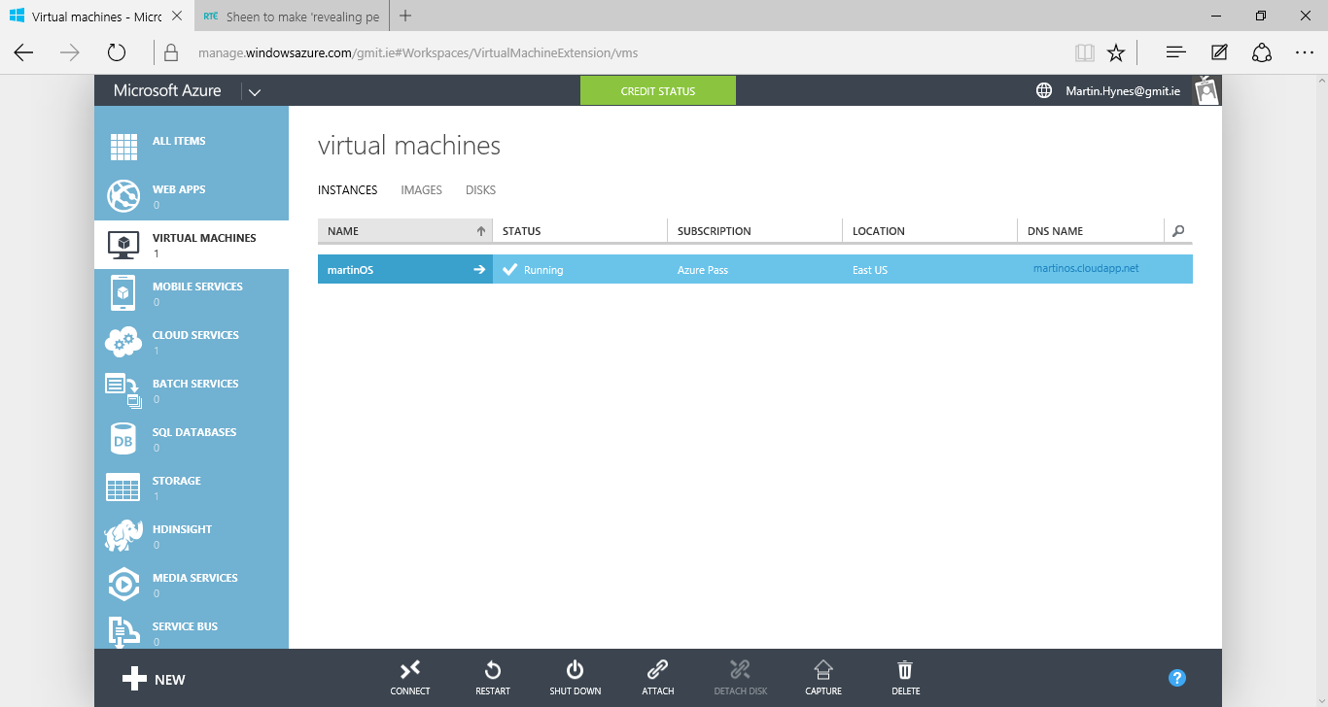

1. Follow the sequence of clicks below.

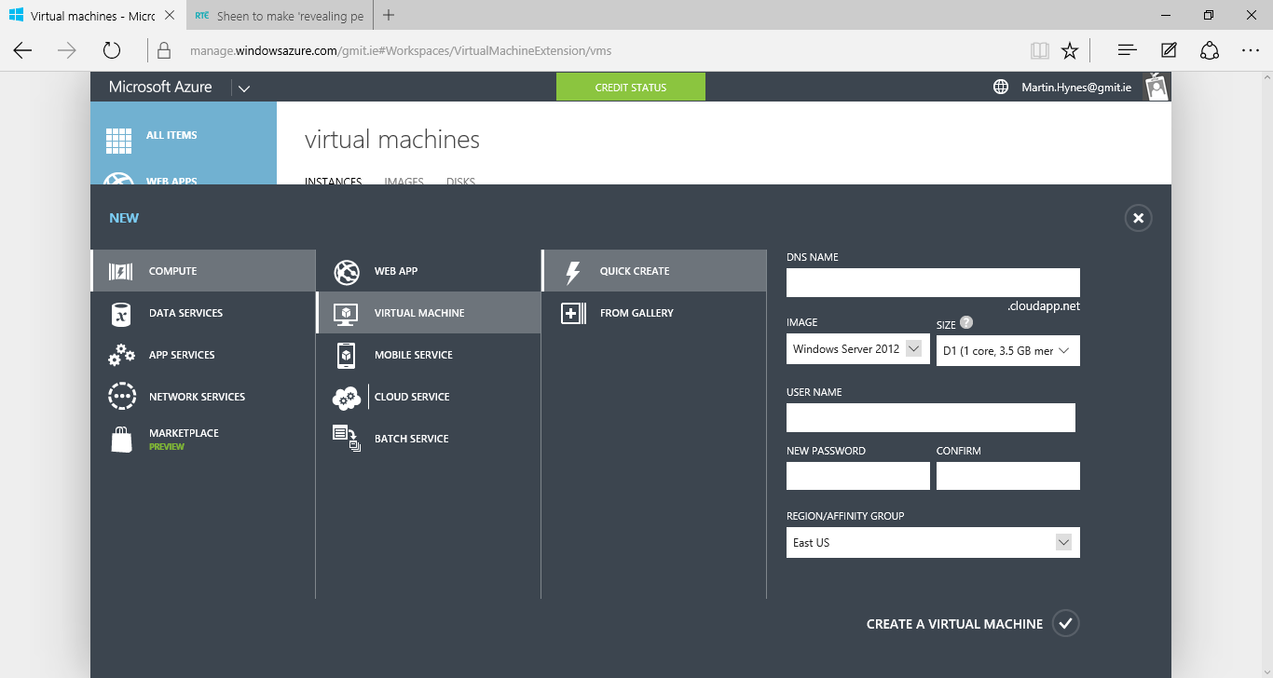

**Remote Desktop**

1. Launch the Remote Desktop Application on your lab pc.
2. Enter your virtual server’s IP Address, Username and Password
3. Press Connect

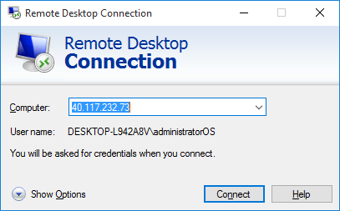

**Running your first Server Application**

1. Download the following two Java files from Moddle
   1. Provider.java
   2. Requester.java
2. Build them on your local machine.
3. Send Provider.class to the remote machine( via email)
4. Open port 2004 for TCP Traffic on the Server
5. Add an endpoint on the virtual server following the step in figures

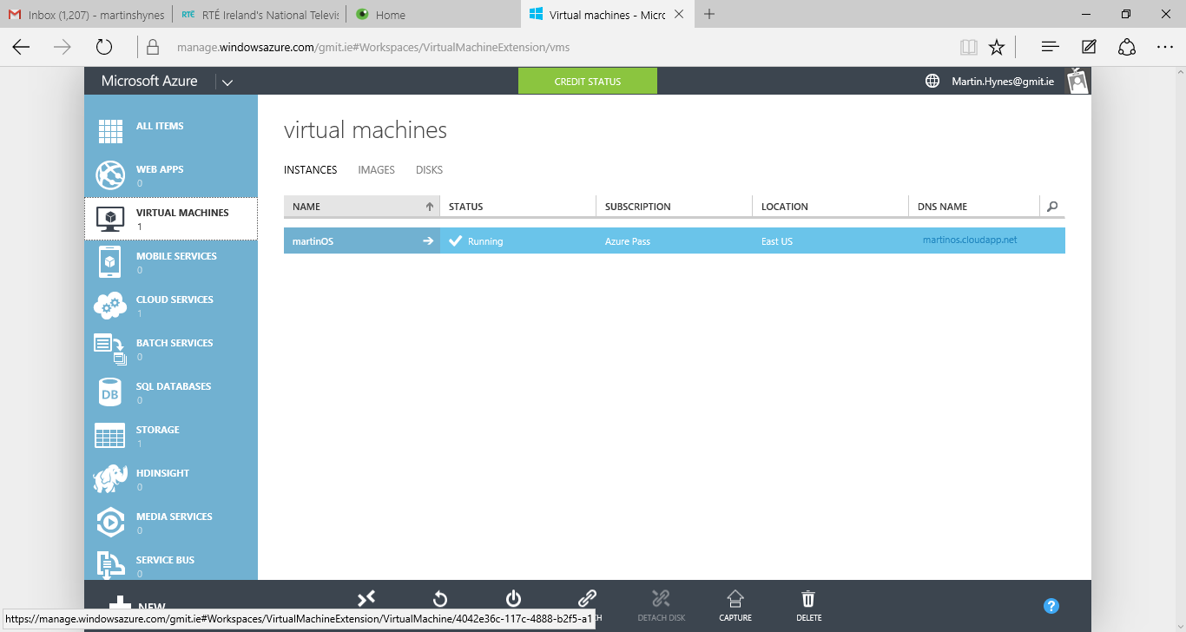

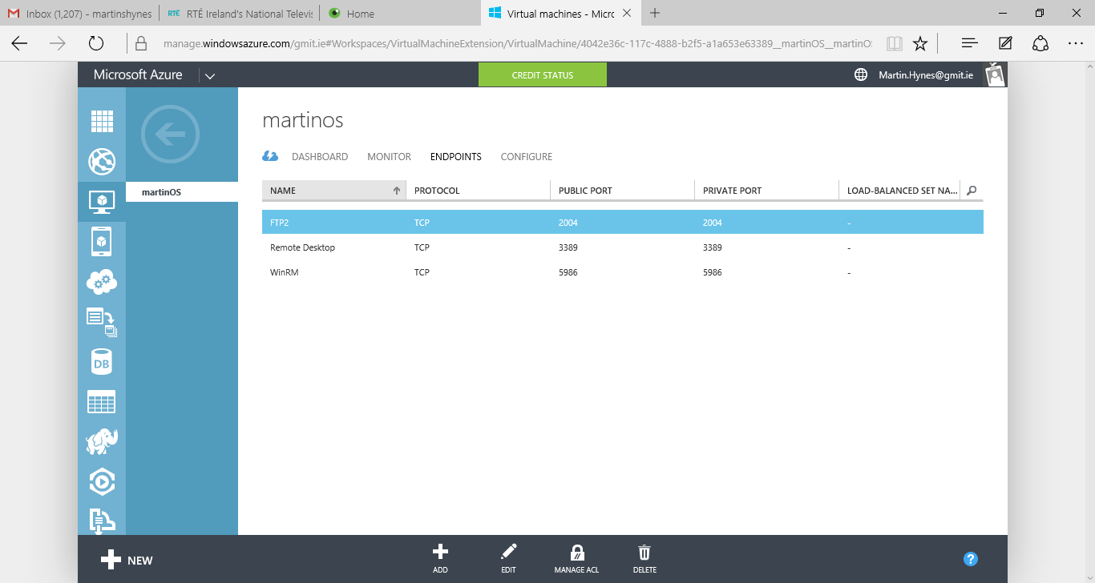

1. Run Provider.class on the server
2. Run Requester.class on the local machine

